**Project Design Phase-II**

**Data Flow Diagram & User Stories**

|  |  |
| --- | --- |
| Date | 11 October 2022 |
| Team ID | PNT2022TMID52282 |
| Project Name | Customer Care Registry |
| Maximum Marks | 4 Marks |

**Data Flow Diagrams:**

A Data Flow Diagram (DFD) is a traditional visual representation of the information flows within a system. A neat and clear DFD can depict the right amount of the system requirement graphically. It shows how data enters and leaves the system, what changes the information, and where data is stored.

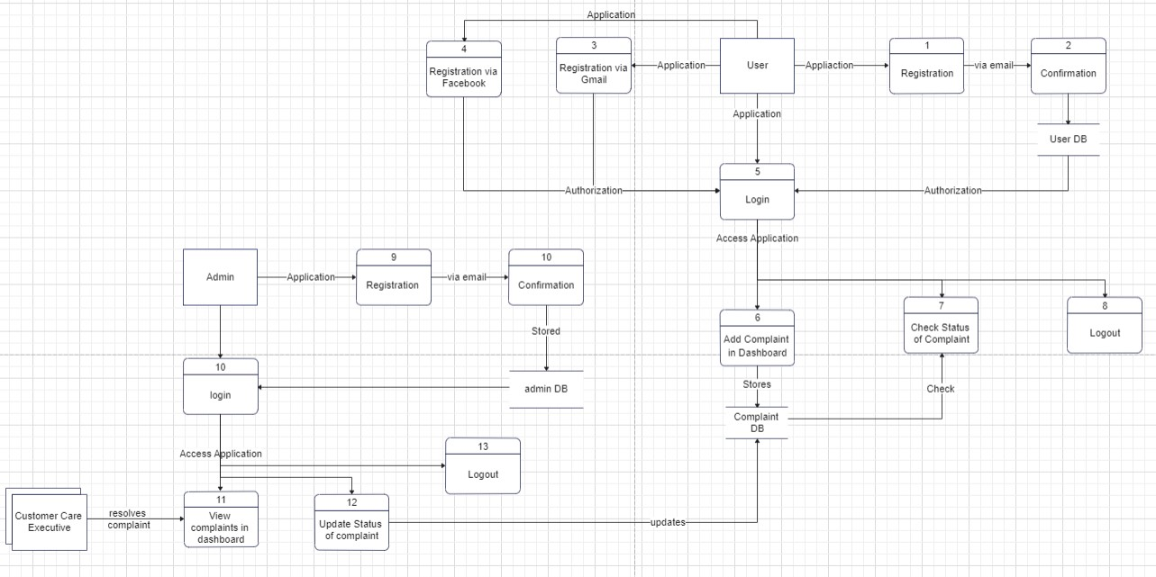

**User Stories**

| **User Type** | **Functional Requirement (Epic)** | **User Story Number** | **User Story / Task** | **Acceptance criteria** | **Priority** | **Release** |
| --- | --- | --- | --- | --- | --- | --- |
| Customer (Web user) | Registration | USN-1 | As a user, I can register for the application by entering my email, password, and confirming my password. | I can access my account / dashboard | High | Sprint-1 |
|  |  | USN-2 | As a user, I will receive confirmation email once I have registered for the application | I can receive confirmation email & click confirm | High | Sprint-1 |
|  |  | USN-3 | As a user, I can register for the application through Facebook | I can register & access the dashboard with Facebook Login | Low | Sprint-2 |
|  |  | USN-4 | As a user, I can register for the application through Gmail |  | Medium | Sprint-2 |
|  | Login | USN-5 | As a user, I can log into the application by entering email & password |  | High | Sprint-1 |
|  | Dashboard | USN-6 | As a user , I can register the complaint in the register complaint page | I can register complaint(s) | High | Sprint-1 |
|  |  | USN-7 | As a user , I can view the status of the complaint. | I can view status of complaint | Medium | Sprint-1 |
|  |  | USN-8 | As a user, I can logout of the application | I can logout from the application | Low | Sprint-2 |
| Customer Care Executive | Dashboard | USN-8 | As a customer care Executive, I can resolve a complaint registered by user. | I can provide solution to a problem. | High | Sprint -1 |
| Administrator | Registration | USN-9 | As an admin, I can register for the application by entering my email, password, and confirming my password. | I can access my account / dashboard | High | Sprint-1 |
|  |  | USN-10 | As an admin, I will receive confirmation email once I have registered for the application | I can receive confirmation email & click confirm | High | Sprint-1 |
|  | Login | USN-11 | As an admin I can log into the application(admin panel) by entering email & password |  | High | Sprint-1 |
|  | Dashboard | USN-12 | As an admin, I can update the status of the complaint to the user with the help of customer care executive. | I can satisfy the customer on his/her query. | Medium | Spritn-2 |
|  |  | USN-13 | As an admin , I can logout from the application | I can logout from the application | Low | Sprint -2 |